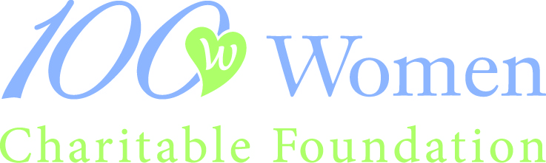

2017 LETTER OF INTENT TO APPLY FOR GRANT FUNDING

Applicant organization must be based in Santa Clara or San Mateo counties, or may be the recognized local chapter of a state or national charity serving this region. The proposed project or program must be implemented in and serve residents of one or more of these counties, and all monies must be expended in these counties. Applicant organization must be in operation for three or more years (according to date on 501C3) and 2016 Impact Grant winners are not eligible for 2017 grants.

Applicants may not request funding for any of the following activities or expenditures:
1.Endowment funding 2.Debt reduction or operational deficits 3. Grants to individuals
4.Partisan, legislative, or political activity 5.Religious outreach or evangelical programs
6.Projects whose sole purpose is to fund athletics or visual & performing arts

Funds must be expended within 24 months of the grant award date.
If your project is selected to receive a grant award, you must furnish 100 Women Charitable Foundation with a report showing how these funds were used specifically for the purpose for which the grant is sought.

An organization may submit only one application each year. This form must be emailed by midnight May 31, 2017. NOTE: We will only accept 45 applications and they will be considered on a date-received basis.

The 100 Women Charitable Foundation Referring Member must be a current 2017 member. We will be contacting ALL referring members to notify her of your LOI.

Name and email of referring Member; ________________________________________________

Legal Name of Organization: ______________________________________________________

Organization Complete Address: __________________________________________________

Phone and Website: _____________________________________________________________

Year on your IRS 501(c)(3): _______________________________________________________

Specific Project Title: ____________________________________________________________

Project Director/contact person and Title: ___________________________________________

Phone ______________________________ email _____________________________________

Please limit your responses to one page for the following questions. LOI cannot exceed 2 pages.

If the project you are requesting funds for has a separate operating budget please list both the program budget as well as the organization budget here, we need the actual $$ amounts:

Program Budget _______________________________

Organizational Budget __________________________

Briefly describe what the grant monies will be used for:

Briefly describe specifically whom this project will serve:

Briefly describe, as specifically as possible, how many this project will serve:

Briefly describe the goals of this project:

I certify that this organization is an IRS 501(c)(3) public charity and that all above information is accurate and verifiable.

_______________________________________________________________________
Name Position

_______________________________________________________________________
Signature Date

Please complete this form, attach a copy of the IRS letter affirming your organization’s not-for-profit status, and submit this form via email to:
vrmtnr@aol.com

THIS COMPLETED FORM MUST BE EMAILED
NO LATER THAN MIDNIGHT, MAY 31, 2017

