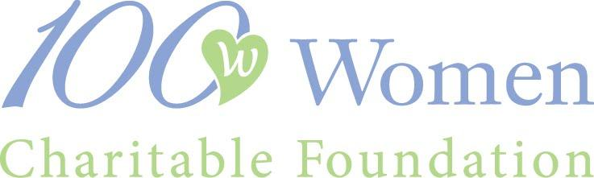

2024 LETTER OF INQUIRY – REQUEST for APPLICATION

Applicant organizations must be based in Santa Clara or San Mateo counties or may be the recognized local chapter of a state or national charity serving this region. The proposed project or program must be implemented in and serve residents of one or both of these counties, and all monies must be expended in these counties. Programs should have a significant and long-term positive effect on our community and benefit an underserved or disadvantaged population. Applicant organizations must be a recognized non-profit for three or more years (according to date on 501C3) by March of 2025, and 2023 Impact Grant winners are not eligible to apply for 2024 grants.

Applicants may not request funding for any of the following activities or expenditures:
1. Endowment funding
2. Debt reduction or operational deficits
3. Grants to individuals
4. Partisan, legislative, or political activity
5. Religious outreach or evangelical programs
6. Projects whose sole purpose is to fund athletics or visual & performing arts

Applicants must have a minimum organization budget of $100,000 and a minimum project budget of $60,000.

Funds must be expended within 12 months of the grant award date (approximately March 2025).

Upon verification of a valid Letter of Inquiry by the 100 Women board, an eligible organization will receive the 2024 100 Women Charitable Foundation grant application. This application must be returned by the application deadline along with the required financials. All complete and validated applications will be reviewed by our grant committees (Education, Family, and Health & Wellness) in the fall of 2024. Four organizations from each committee will be selected for site visits, and from those twelve, six finalists (two from each committee) will be selected to present to membership in early 2025, where members will vote for Impact and Investment Grant recipients.

If your project is selected to receive a grant award, you must furnish 100 Women Charitable Foundation with a report showing how these funds were used specifically for the purpose for which the grant is sought.

An organization may submit only one project each year. This form must be emailed by midnight June 15, 2024.

NOTE: We will accept the first 45 qualified applications submitted by our deadline.

2024 LETTER OF INQUIRY – REQUEST for APPLICATION

The 100 Women Charitable Foundation Referring Member must be a current 2024 member. We will be contacting ALL referring members to notify them of your LOI.

Name and email of Referring Member: _______________________________________________

Legal Name of Organization: ______________________________________________________

Organization Complete Address: __________________________________________________

Phone and Website: _____________________________________________________________

Year on your IRS 501(c)(3): _______________________________________________________

Specific Project Title: ____________________________________________________________

Project Director/Contact Person and Title: ___________________________________________

Phone: _____________________________ Email: _____________________________________

Please complete this form, attach a copy of the IRS letter affirming your organization’s
not-for-profit status, and submit this form via email to:
grants@100womenfoundation.org
THIS COMPLETED FORM MUST BE EMAILED
NO LATER THAN MIDNIGHT, JUNE 15, 2024

Please verify that 100 Women Charitable Foundation’s requirements are met by checking the following boxes:

- Organization operates in Santa Clara or San Mateo counties
  - Proposed Project will be implemented in or serve residents of one or both of these counties
  - Project supports an underserved or disadvantaged population
- Organization must have been in operation as a non-profit for three or more years
- Organization understands our project limitations as described on page 1
- Grant funds will be expended within 12 months if awarded a 2024 Grant
- Organization was not an Impact Grant winner in 2023
- Organization budget is at least $100,000. Enter budget here: _______________
- Project budget is at least $60,000. Enter budget here: _____________________

Please limit your responses for the following questions to no more than one page.

Briefly describe what the grant monies will be used for:

Briefly describe specifically whom this project will serve:

I certify that this organization is an IRS 501(c)(3) public charity and that all above information is accurate and verifiable.

_______________________________________________________________________
Name Position

_______________________________________________________________________
Signature Date

